**Chapter 20 International Finance Questions**

**Use this table to answer the next three questions.**

**The following table shows the number of various foreign currencies required to buy a U.S. dollar in April 2016 and March 2019.**

|  |  |  |
| --- | --- | --- |
|  | Units of Foreign Currency per U.S. Dollar in April 2016 | Units of Foreign Currency per U.S. Dollar in March 2019 |
| Euro per U.S. dollar | 0.8815 | 0.877 |
| Chinese yuan per U.S. dollar | 6.477 | 6.667 |
| Indian rupee per U.S. dollar | 66.468 | 66.667 |
| Japanese yen per U.S. dollar | 109.583 | 111.111 |
| British pounds per U.S. dollar | 0.699 | 0.7858 |

**1. Between April 2016 and March 2019, the U.S. dollar depreciated against the:**

* 1. Euro.
  2. Chinese yuan.
  3. Indian rupee.
  4. Japanese yen.
  5. British pound.

**2. In March 2019, a haircut in Japan cost about 3,500 yen. Using the exchange rates in the above table, that haircut cost approximately ________ U.S. dollars.**

* 1. 12.52
  2. 24.04
  3. 28.10
  4. 31.50
  5. 35.65

**3. In March 2019, a movie ticket in India cost about 250 Indian rupees. Using the exchange rates in the table above, the movie ticket cost approximately ________ U.S. dollars.**

* 1. 3.75
  2. 5.00
  3. 6.25
  4. 8.00
  5. 10.50

**Use this table to answer the next two questions.**

**The following table shows the number of British pounds required to buy one U.S. dollar between January 1, 2019, and August 1, 2019.**

|  |  |
| --- | --- |
| Date | British Pounds Required to Buy 1 U.S. Dollar |
| January 1, 2019 | 0.785 |
| February 1, 2019 | 0.763 |
| March 1, 2019 | 0.754 |
| April 1, 2019 | 0.768 |
| May 1, 2019 | 0.767 |
| June 1, 2019 | 0.792 |
| July 1, 2019 | 0.788 |
| August 1, 2019 | 0.823 |

**4. Between January 1, 2019, and March 1, 2019, the U.S. dollar ________ against the British pound, and the British pound ________ against the U.S. dollar.**

* 1. depreciated; appreciated
  2. appreciated; depreciated
  3. neither appreciated nor depreciated; depreciated
  4. depreciated; depreciated
  5. appreciated; neither appreciated nor depreciated

**5. Between January 1, 2019, and August 1, 2019, the U.S. dollar ________ against the British pound, and the British pound ________ against the U.S. dollar.**

* 1. depreciated; appreciated
  2. appreciated; depreciated
  3. neither appreciated nor depreciated; depreciated
  4. depreciated; depreciated
  5. appreciated; neither appreciated nor depreciated

**6. The claim that the quantity of euros demanded by U.S. consumers will fall when the price of euros in terms of U.S. dollars rises is best referred to as the:**

* 1. law of increasing marginal costs.
  2. hot-hand fallacy.
  3. law of supply.
  4. exchange rate–inflation fallacy.
  5. law of demand.

**7. If interest rates rise in the United States relative to the rest of the world, the demand for U.S. dollars will _____ because there is greater demand for assets with ____ returns.**

* 1. decrease; higher
  2. decrease; lower
  3. increase; higher
  4. increase; lower
  5. stay the same; higher

**8. If interest rates in Germany decrease relative to the rest of the world, it means that German bonds will now provide a ________ return, and ________ for these bonds will ________.**

* 1. higher; supply; decrease
  2. higher; supply; increase
  3. higher; demand; increase
  4. lower; demand; decrease
  5. lower; demand; increase

**Use this graph to answer the next two questions.**

**The following graph depicts the demand for Chinese yuan in the foreign currency exchange market.**

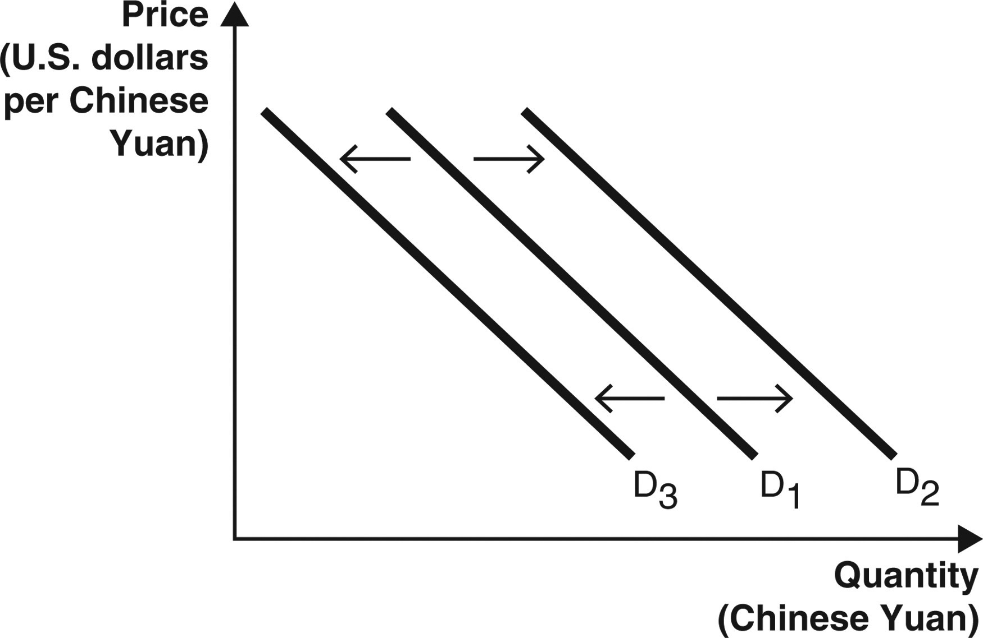

**9. If the interest rates in China rise relative to interest rates in the United States, the demand curve above:**

* 1. will not shift because interest rates are not related to exchange rates.
  2. will not shift because interest rates only affect the supply curve.
  3. can either increase from D1 to D2 or decrease from D1 to D3.
  4. will increase from D1 to D2.
  5. will decrease from D1 to D3.

**10. If the interest rates in China fall relative to interest rates in the United States and, at the same time, U.S. consumers’ demand for Chinese goods decreases, the demand curve above:**

* 1. will not shift because interest rates are not related to exchange rates.
  2. will not shift because interest rates only affect the supply curve.
  3. can either increase from D1 to D2 or decrease from D1 to D3.
  4. will increase from D1 to D2.
  5. will decrease from D1 to D3.

**Use these graphs to answer the next two questions.**

**The arrows in Graphs A and B represent possible movements of the exchange rate (euros per U.S. dollar) and the quantity of U.S. dollars buyers are willing and able to buy.**

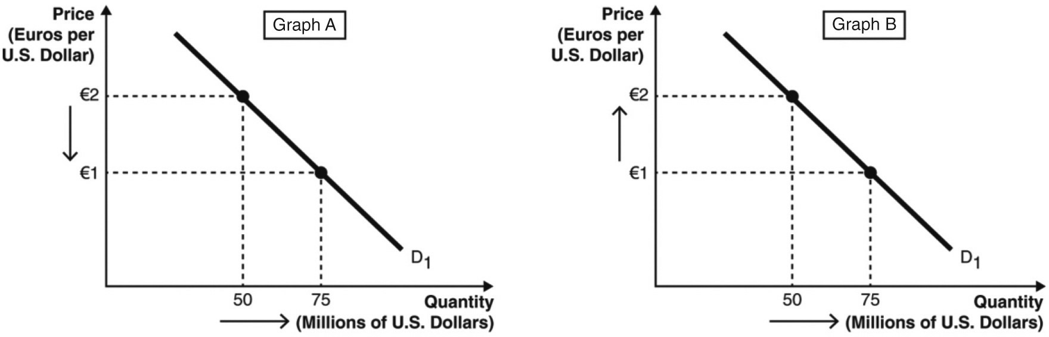

**11. A depreciation of the euro against the U.S. dollar is represented by Graph ______, and a depreciation of the U.S. dollar against the euro is represented by Graph ______.**

* 1. A; A
  2. A; B
  3. B; A
  4. B; B
  5. None of these are correct.

**12. An appreciation of the euro against the U.S. dollar is represented by Graph ______, and a depreciation of the U.S. dollar against the euro is represented by Graph ______.**

* 1. A; A
  2. A; B
  3. B; A
  4. B; B
  5. None of these are correct.

**13. To maintain a pegged exchange rate in China:**

* 1. the Chinese government must prevent Chinese citizens from trading goods or services with other countries.
  2. the Chinese government must prevent Chinese citizens from purchasing assets denominated in foreign currencies.
  3. the Chinese government must adjust the supply of the yuan in world markets.
  4. at least one foreign country must also maintain a pegged exchange rate.
  5. no other country with which China shares a geographical border can maintain a pegged exchange rate.

**The graph below depicts the supply of U.S. dollars in the foreign currency exchange market.**

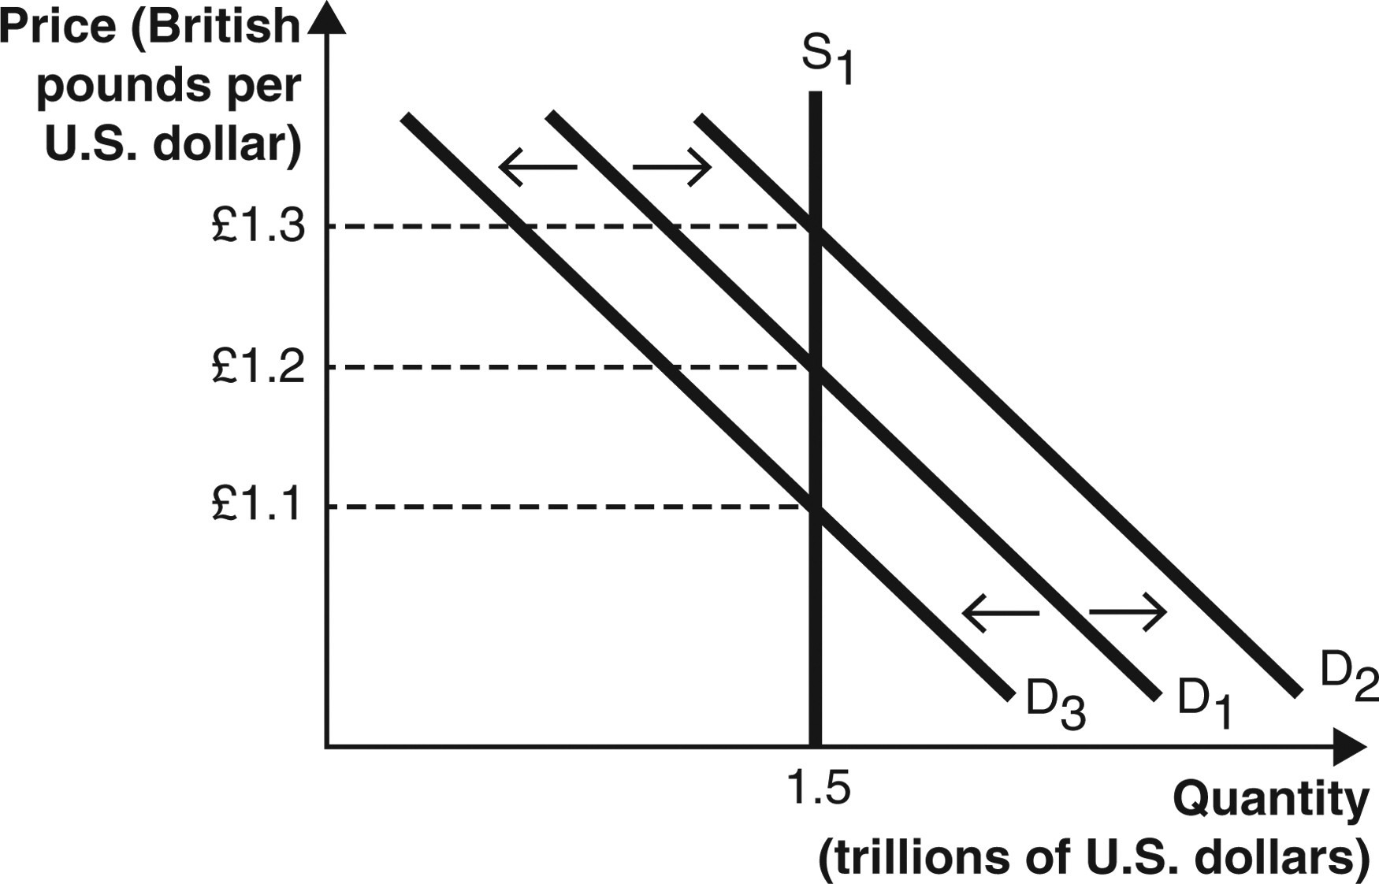

**14. A shift from D1 to D3 in the above graph could have been caused by a(n):**

* 1. decrease in the exchange rate from £1.2/$1 to £1.1/$1.
  2. increase in the exchange rate from £1.1/$1 to £1.2/$1.
  3. increase in demand for U.S. assets relative to British assets.
  4. increase in U.S. interest rates relative to British interest rates.
  5. decrease in British consumers’ demand for U.S. goods.

**Use this graph to answer the next two questions.**

**The following graph depicts the supply of U.S. dollars in the foreign currency exchange market.**

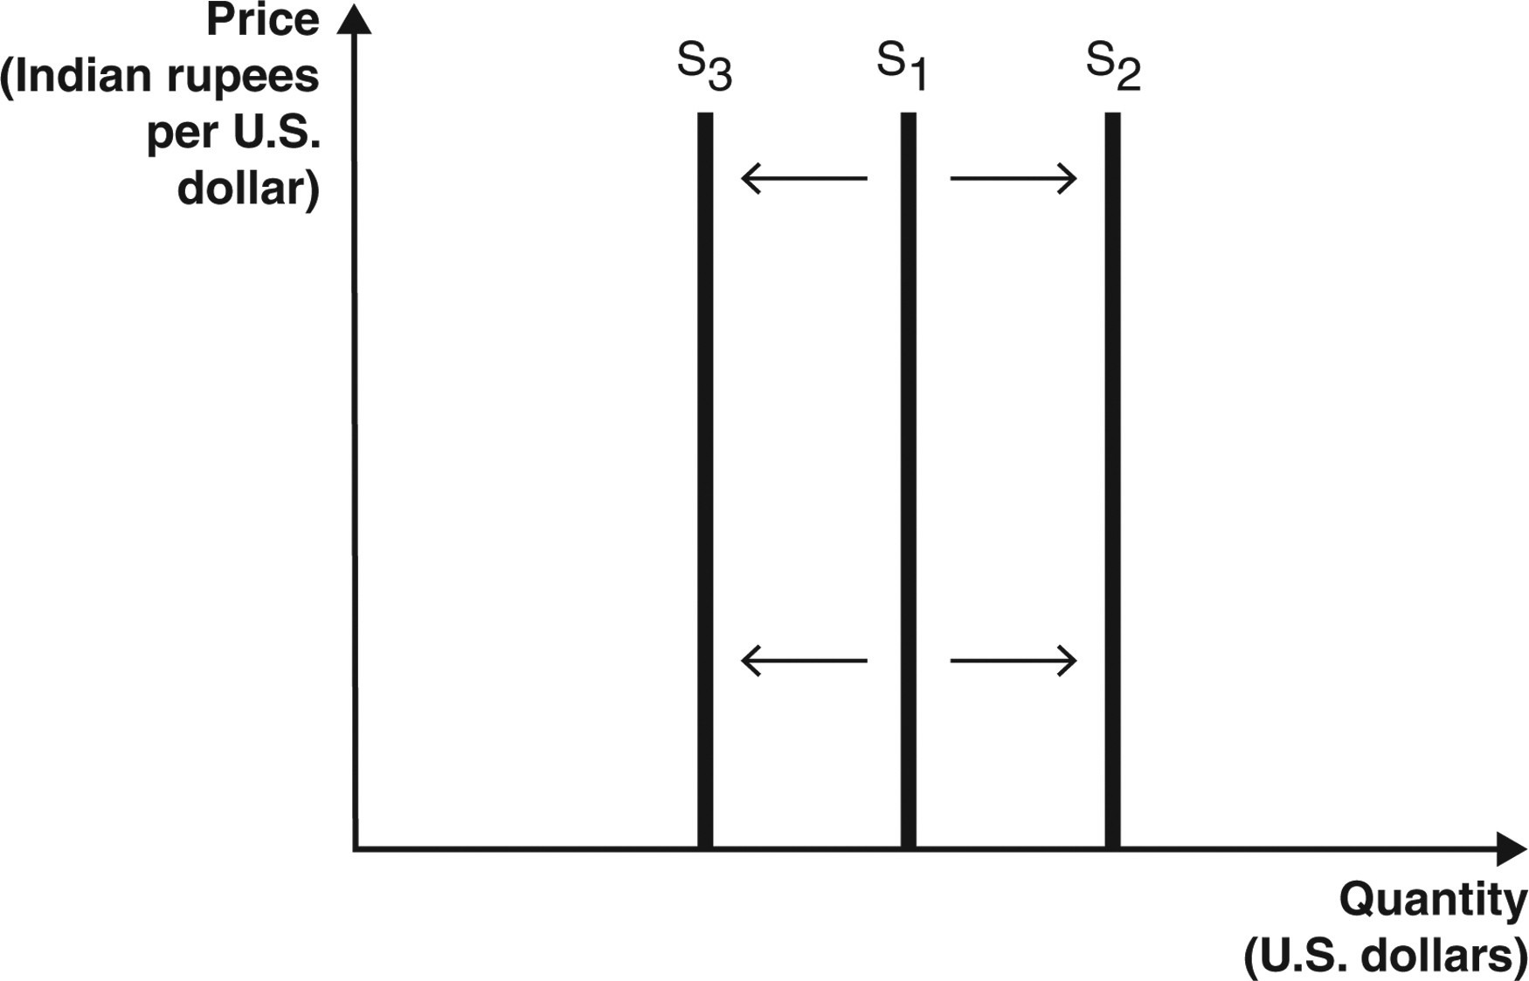

**15. The U.S. central bank has the power to increase or decrease the supply of U.S. dollars. If the U.S. central bank increases the supply of U.S. dollars, the supply curve in the above graph will ________; if the U.S. central bank decreases the supply of U.S. dollars, the supply curve in the above graph will ________.**

* 1. shift rightward; shift leftward
  2. shift leftward; shift rightward
  3. shift rightward; also shift rightward
  4. shift leftward; also shift leftward
  5. not shift; not shift

**16. If the U.S. central bank decreases the supply of U.S. dollars, the supply curve in the above graph will ________; if the Indian central bank increases the supply of rupees, the supply curve in the above graph will ________.**

* 1. shift leftward; also shift leftward
  2. shift rightward; not shift
  3. not shift; shift rightward
  4. shift rightward; shift leftward
  5. shift leftward; not change

Use these graphs to answer the next two questions.

The graph below depicts the three possible aggregate demand curves.

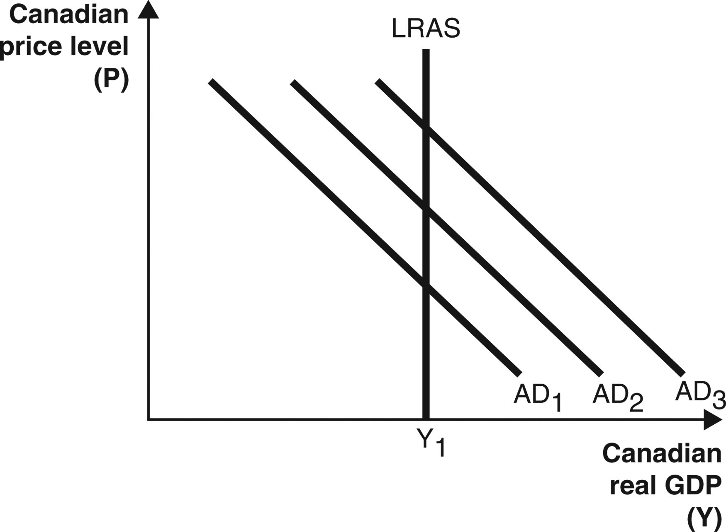

**17. If Canada’s central bank prints ________ Canadian dollars, the Canadian dollar will depreciate, and the aggregate demand curve will ________.**

* 1. more; shift from AD2 to AD3
  2. more; shift from AD2 to AD1
  3. less; shift from AD2 to AD3
  4. more; not shift
  5. less; not shift

**18. In the short run, ________ would increase domestic aggregate demand (AD) in the context of the aggregate supply-aggregate demand model.**

* 1. an increase in the value of the domestic currency against all foreign currencies
  2. a depreciation of the domestic currency against all foreign currencies
  3. an appreciation of the domestic currency against all foreign currencies
  4. a depreciation of all foreign currencies against the domestic currency
  5. either an increase or decrease in domestic government spending

**Use this graph to answer the next question.**

**West Virginia potatoes are sold in West Virginia and all other U.S. states. The following graph depicts the market for the potatoes in West Virginia. Assume there are similar markets for the potatoes in all other U.S. states and that the potatoes sold in all states are identical. Further, assume potato sellers incur zero costs to transport potatoes between any U.S. states and that there are no other barriers to trade.**

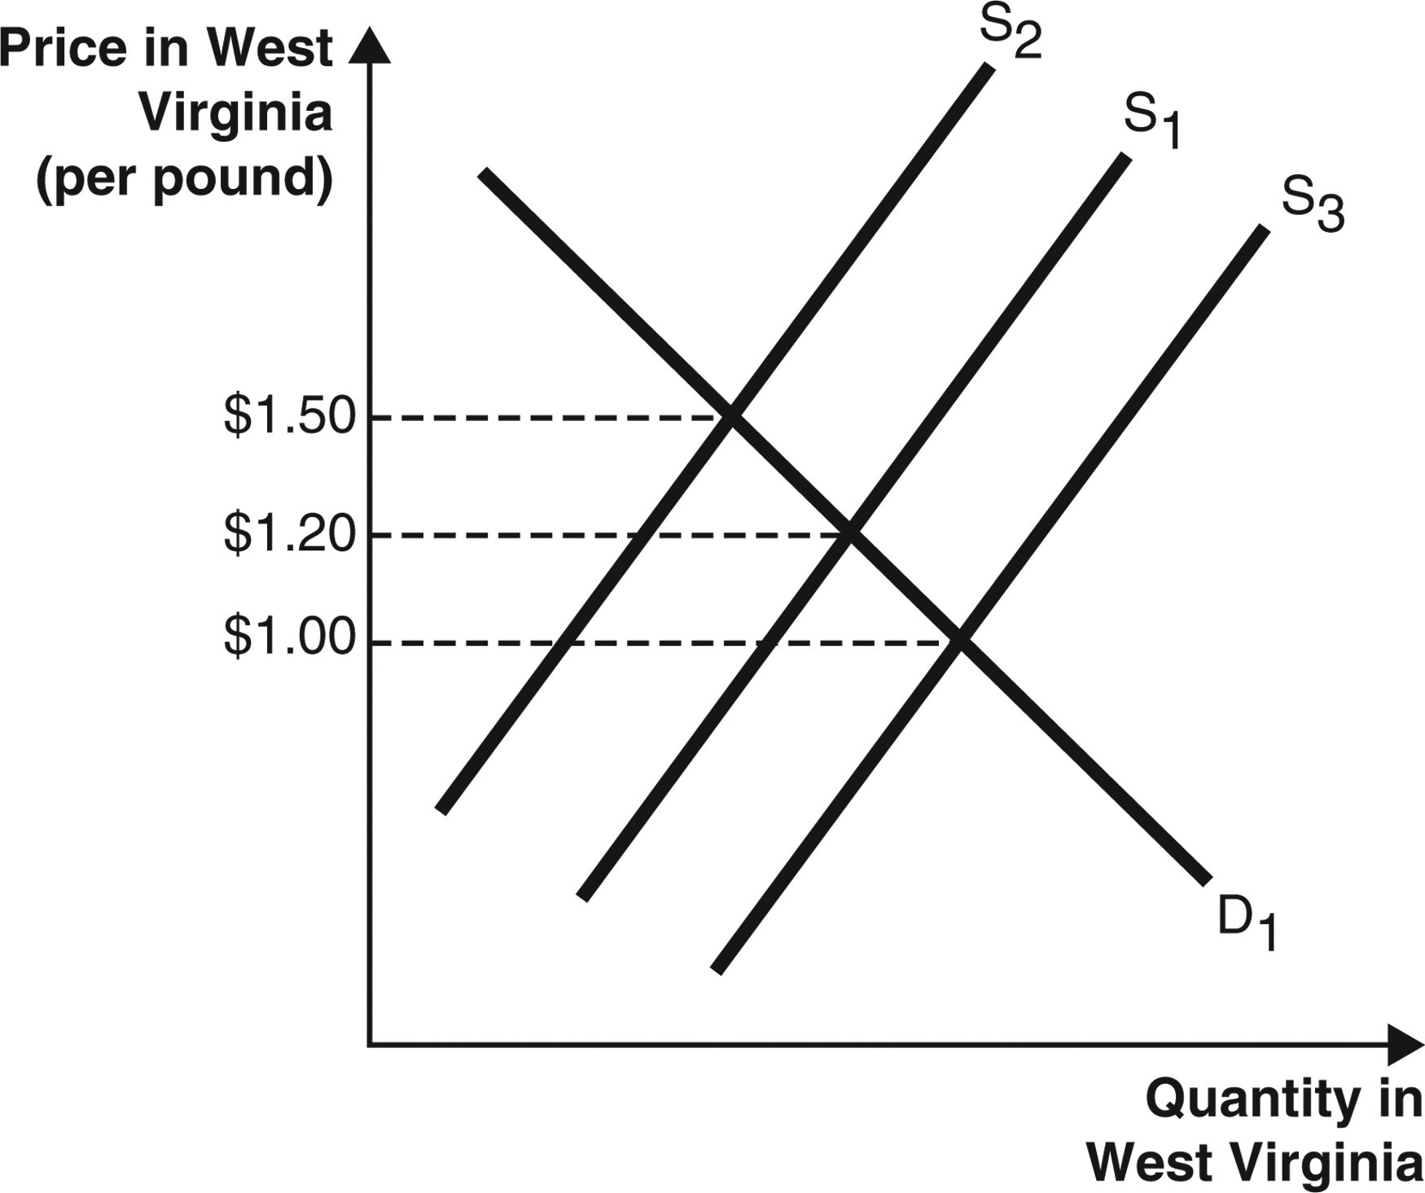

**19. Initially, the price of potatoes in West Virginia is $1.20, while the same potatoes sell for $1.75 in all other states. In this case, the supply in West Virginia will _____ & supply in other states will _____. This is reflected in the graph as the shift from S1 to ______.**

* 1. increase; increase; S3
  2. increase; decrease; S3
  3. increase; decrease; S2
  4. decrease; increase; S2
  5. decrease; decrease; S2

**20. Assuming the theory of purchasing power parity holds, what is the exchange rate between the United States and Mexico if the price of an identical avocado costs $2 in the United States and 40 pesos in Mexico?**

* 1. $0.05 per peso
  2. $0.20 per peso
  3. $2.00 per peso
  4. $4.00 per peso
  5. $20.00 per peso

**21. Assuming the theory of purchasing power parity holds, what is the exchange rate between the United States and Mexico if the price of an identical avocado costs $2 in the United States and 40 pesos in Mexico?**

* 1. 0.05 pesos per dollar
  2. 2.00 pesos per dollar
  3. 20.00 pesos per dollar
  4. 32.50 pesos per dollar
  5. 40.00 pesos per dollar

**Use these graphs to answer the next three questions.**

**The following two graphs depict the equilibrium price of a pound of California grapes sold in California and West Virginia, respectively. Assume the types and quality of the grapes being sold in the two states are identical. Further, assume grape sellers incur zero costs to transport grapes between the two states and there are no other barriers to trade.**

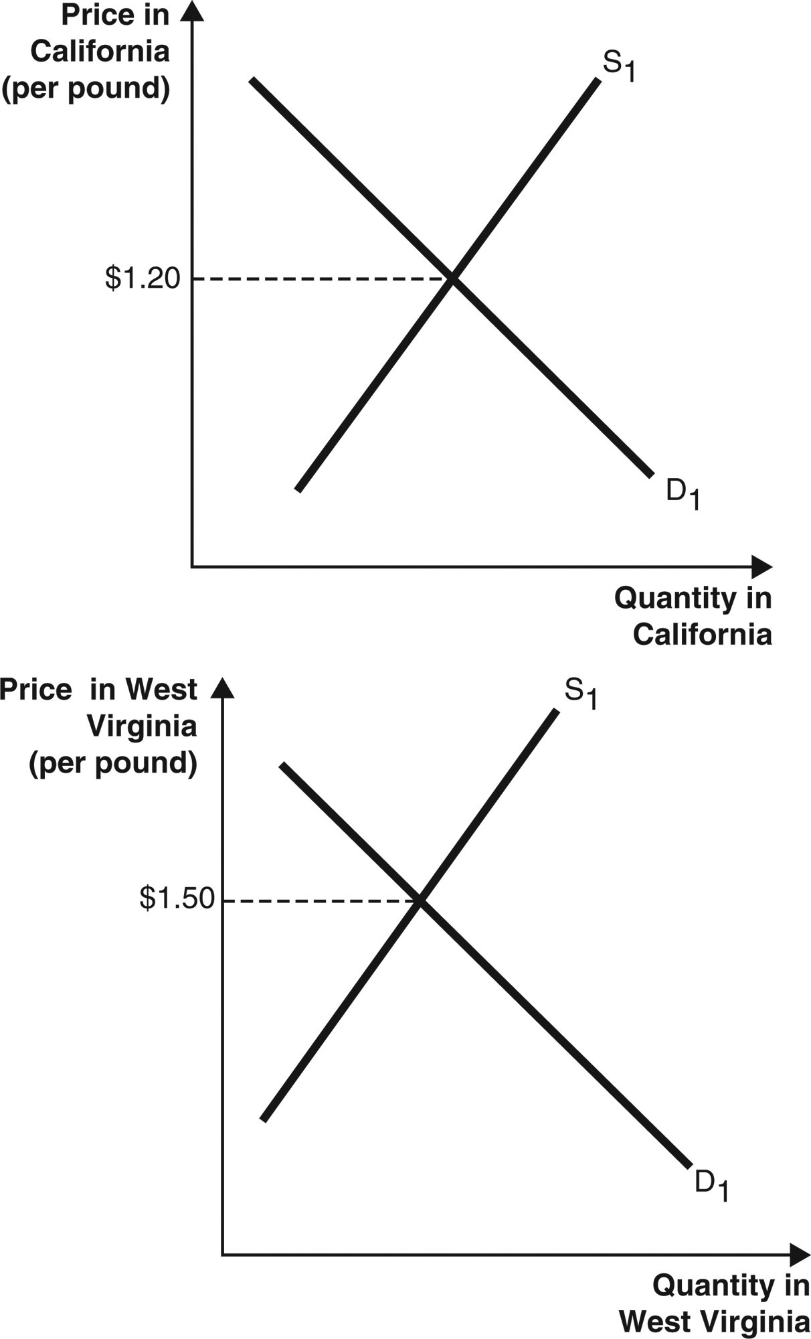

**22. According to the law of one price, the price of grapes will ________ in California and** ________ in West Virginia.

* 1. increase; increase
  2. increase; decrease
  3. stay the same; increase
  4. decrease; increase
  5. decrease; decrease

**23. Which of the following pairs of prices is consistent with the law of one price?**

* 1. California price: $0.50; West Virginia price: $0.80
  2. California price: $0.80; West Virginia price: $0.80
  3. California price: $1.20; West Virginia price: $1.20
  4. California price: $1.35; West Virginia price: $1.35
  5. California price: $1.50; West Virginia price: $1.50

**24. According to the law of one price, the supply curve in the California grape market will ________, and the supply curve in the West Virginia grape market will ________.**

* 1. shift right; shift right
  2. shift left; shift left
  3. not shift; shift left
  4. shift right; shift left
  5. shift left; shift right

**25. Suppose that a Sony PlayStation (manufactured in Japan and exported worldwide) sells for a lower price in China than in the United States. What is the most likely reason for the difference in prices in the two locations?**

* 1. China institutes price controls on goods and services sold within the country.
  2. Shipping the PlayStation to the United States is more expensive than shipping it to China.
  3. The PlayStation sold in China is different from the one sold in the United States.
  4. Chinese citizens have a much stronger demand for the PlayStation than U.S. citizens do.
  5. Japan has a closer political relationship with China, so China receives a discount on the PlayStations compared to the United States.

**26. Which of the following is considered nontradable?**

* 1. bananas from Mexico
  2. a bottle of wine from Italy
  3. a share of stock in Google
  4. a truck from the United States
  5. childcare services in Canada

**27. A consumer in the United States purchases a car produced in Japan. How would this transaction be recorded?**

* 1. as an increase in the U.S. current account
  2. as a decrease in the U.S. current account
  3. as an increase in the U.S. capital account
  4. as a decrease in the U.S. capital account
  5. The transaction is not recorded because there is no exchange of services.

**28. What is the key identity of the balance of payments?**

* 1. current account balance - capital account balance = 0
  2. current account balance + capital account balance = 0
  3. capital account balance - current account balance = 0
  4. current account balance > capital account balance
  5. current account balance < capital account balance

**29. Suppose a Mexican citizen buys a Ford truck from America and Ford (an American company) decides to hold on to the Mexican currency. How will this transaction enter into the U.S. balance of payments?**

* 1. as an increase in current account and as a decrease in capital account
  2. as a decrease in current account and as an increase in capital account
  3. as an increase in current account and as an increase in capital account
  4. as a decrease in current account and as a decrease in capital account
  5. there will be no net change in current account or capital account

**30. Suppose a Chinese citizen buys a box of Nestlé Kit Kat candy bars from America and Nestlé (an American company) uses the currency to buy Chinese-produced machinery. How will this transaction enter into the U.S. balance of payments?**

* 1. as an increase in current account and as an increase in capital account
  2. as a decrease in current account and as an increase in capital account
  3. as an increase in current account and as a decrease in capital account
  4. as a decrease in current account and as a decrease in capital account
  5. there will be no net change in current account or capital account

**31. Suppose an American citizen purchases a TV from Sony (a Japanese company). Sony then uses the dollars to purchase U.S. Treasury bonds. How will this transaction enter into the U.S. balance of payments?**

* 1. the current account will decrease; the capital account will increase
  2. the current account will decrease; the capital account will decrease
  3. the current account will increase; the capital account will increase
  4. the current account will increase; the capital account will decrease
  5. There will be no net change in the current account or capital account.

**32. Suppose the United States experiences a significant recession. What would you expect to happen to the balance of payments for the United States in this situation?**

* 1. The current account increases and capital account decreases.
  2. The current account increases and capital account increases.
  3. The current account decreases and capital account increases.
  4. The current account decreases and capital account decreases.
  5. Domestic business cycles do not affect the international balance of payments for the United States.

**33. Assume that a country currently has a trade deficit. If that country experiences a recession, what would we expect to happen to the trade deficit?**

* 1. Nothing, because recessions do not impact the trade deficit.
  2. Imports tend to be higher during this time, which increases the trade deficit.
  3. Exports tend to be lower during this time, which decreases the trade deficit.
  4. Exports tend to be higher during this time, which increases the trade deficit.
  5. Imports tend to be lower during this time, which decreases the trade deficit.

**34. Assume that a country currently has a trade surplus. If that country experiences an expansion in economic activity, what would we expect to happen to the trade surplus?**

* 1. Nothing, because expansions do not impact the trade surplus.
  2. Imports tend to be higher during this time, which decreases the trade surplus.
  3. Exports tend to be lower during this time, which increases the trade surplus.
  4. Exports tend to be higher during this time, which decreases the trade surplus.
  5. Imports tend to be lower during this time, which increases the trade surplus.

**35. What are three primary causes of current account deficits?**

* 1. strong economic growth, lower personal savings rates, and fiscal policy
  2. strong investment, fiscal policy, and personal savings rates
  3. consumer preferences, trade barriers, and transportation costs
  4. trade deficit, consumer preferences, and fiscal policy
  5. a weak export market, increased consumer wealth, and monetary policy

**36. How can strong economic growth cause a current account deficit?**

* 1. A strong economy means a larger supply of domestic goods, which increases exports.
  2. A strong economy means consumers can afford more imports.
  3. A strong economy permits increased savings.
  4. A strong economy causes a government budget surplus.
  5. A strong economy decreases the need for investment.

**37. How can domestic savings rates cause a current account deficit?**

* 1. High domestic savings rates fuel import purchases.
  2. High domestic savings rates fuel export purchases.
  3. Lower domestic savings rates leave space for foreign investment.
  4. Lower domestic savings rates increase government budget deficits.
  5. Lower domestic savings rates decrease economic growth and imports.

**38. Many countries deliberately intervene in foreign currency markets in an attempt to manipulate the value of their own currencies. How is a country able to devalue its currency? What is one advantage and one disadvantage of this type of intervention?**

1. **Suppose an Australian citizen buys five kegs of Bitburger beer from Germany. Explain what happens to the German balance of payments in each of the following scenarios:**

**A) Bitburger decides to keep the Australian dollars.**

**B) Bitburger uses the proceeds to buy an abandoned factory in America to expand its operations overseas.**

**40. Why might a large capital account surplus be considered bad for an economy?**

**41. Suppose there is a large increase in the demand for electronic goods produced in South Korea. Explain how this will affect the demand for South Korean won (currency) and the exchange rate.**

**42. Briefly describe the concept of purchasing power parity. Assuming the theory of purchasing power parity holds, what is the exchange rate between the United States and Europe if the price of an identical shirt costs $30 in the United States and 25 euros in Europe?**

**43. Suppose a U.S. citizen buys a Subaru car from Japan for $35,000. Subaru, a Japanese company, uses the currency to buy $35,000 worth of U.S.-produced machinery. How will these transactions affect the U.S. current account and U.S. capital account?**